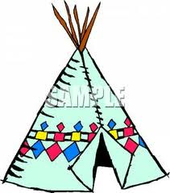 Native American Dwelling Project

I wanted to inform you ahead of that I am planning an extra credit project on Native Americas. This is the first time I will be doing this project and I am very excited about it. The project will be due November 9, 2012.

The children will have an opportunity to have a new learning adventure. This learning adventure will earn you extra credit in Social Studies. This project integrates art, social studies, science and language arts. You will have an opportunity to research and create a Native American dwelling for social studies. This project will enrich you with history about Native Americans. It will also demonstrate your artistic abilities while using natural supplies to create your dwellings. You will practice your language art skills by writing important facts about the homes you create and a report about the natives that lived in those dwellings. This is not mandatory but it will be an enriching opportunity to learn more about Native Americans.
Expectations for projects:
- Choose the dwelling of your choice.
- Create a dwelling using natural resources that the Native Americans may have used.
- Write important facts about the Natives that lived in your dwelling.
- When your project is complete, you will share the information you learned with your peers. Then, your projects will be displayed in the hall for all others to enjoy.
- I will also post them on the website for grandparents to enjoy.
- Report is to be hand written in your own words not copied from source.
- Please do not send dwellings until due date because I don’t have any room to store them now.

We will also be making rain sticks so I will need empty large foil rolls to make them. If you can begin saving them, I would greatly appreciate your assistance. Please send them when you have them available. I will hold on to them until we need them for our project. Thanks for your help.

Here are a couple of websites about Native American dwellings.
http://www.native-languages.org/houses.htm

http://nativeamericans.mrdonn.org/homes.html

I hope this will be an enriching experience.

Sincerely,
Mrs. Cavazos

