Mrs. Cavazos’ Weekly Newsletter #26
Monday | Tuesday | Wednesday | Thursday | Friday
Monday Morning Assembly 7:45-8:00.  Math Homework goes home and remember to read daily 15-20 minutes and document in reading log.  Audrey is the Star of the Week! |  | 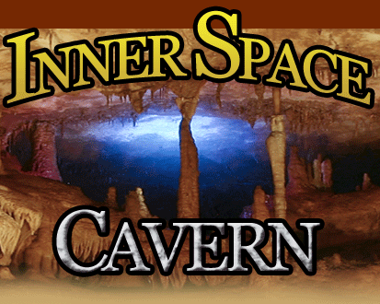  Finally, we are going on a field trip to Inner Space Cavern!!!  Don’t forget to dress appropriate and wear tennis shoes. | Homework is due.  Library day don’t forget your books. 1:45-2:30 | Monday Morning Assembly 7:45-8:00.  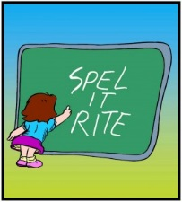  Spelling Test  Have a Happy Spring Break!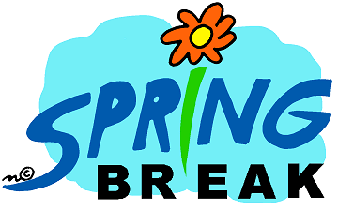  I will see you all in a week.
3/3/14  PE | 3/4/14  Music | 3/5/14  Art | 3/6/14  PE | 3/7/14  Music
Dear Parents,
I hope everyone had a wonderful weekend. It sure is a little chilly today. I hope we will not have another late day. We will be going on our field trip this Wednesday. This is one of my favorite field trips which should have happened with our rock lesson but due to weather conditions we had to postpone. Though it is a little late, it is always fun to go and we learn a lot from our tour guides. I have informed the children of expectations on the bus, in the cave and overall behaviors while the guide is speaking. Mrs. Korsgaard will be our chaperone on this field trip. Don’t forget we will need a sack lunch. Send an extra snack because the children will be hungry after all that walking. Try to get a snack that is high in protein so it will last a little longer.
Thank you parents for attending Science Movie Lunch Bunch! We always learn new things about science.
Willow did such a fabulous job leading the class! She showed leadership skills and modeled what a good student does to learn. Thank you Willow for a job well done!
I sent home some extra math for practice. Students will have two math homework worksheets. One is a review of what we learned last week and the other are skills we need to continue to work on. Thanks for your support!
Academic Focus:
Math-
Week 26 & 27 Problems and Number Sentences
Week 28 Problems and Properties of Numbers
Science:
Week 26-36 Organisms & Environments
Language Arts:
Reading-comprehension, drawing conclusions, making inferences, Identifying important details, and retelling events, vocabulary
Writing- Poetry, use rhythm, rhyme and alliteration.
Social Studies: Women’s History and Leadership
Spelling Words: Rules for K sound.
The (k) sound before a,o,u,or a consonant= c (cup)
The (k) sound before e, I, or y = k (kite)
The medial (k) sound before e after a short vowel = ck (ticket)
cap, clap, fact, act, scat, clip, class, kit, kept, skip, kiss, skin, skill, kink, skim
Challenge Words: ticket, jacket, cricket
We also have 2 field trips scheduled:
March 5, 2014- Inner Space Cavern (Deim K.)
March 31, 2014- Capital (Leah P.)
Have a Great Week!
Mrs. Cavazos

