Mrs. Cavazos’ Weekly Newsletter #27
Monday | Tuesday | Wednesday | Thursday | Friday
Monday Morning Assembly 7:45  Math Homework sent home today. Research homework was sent last week. All due on Thursday. Please remember to read daily and document in reading log.  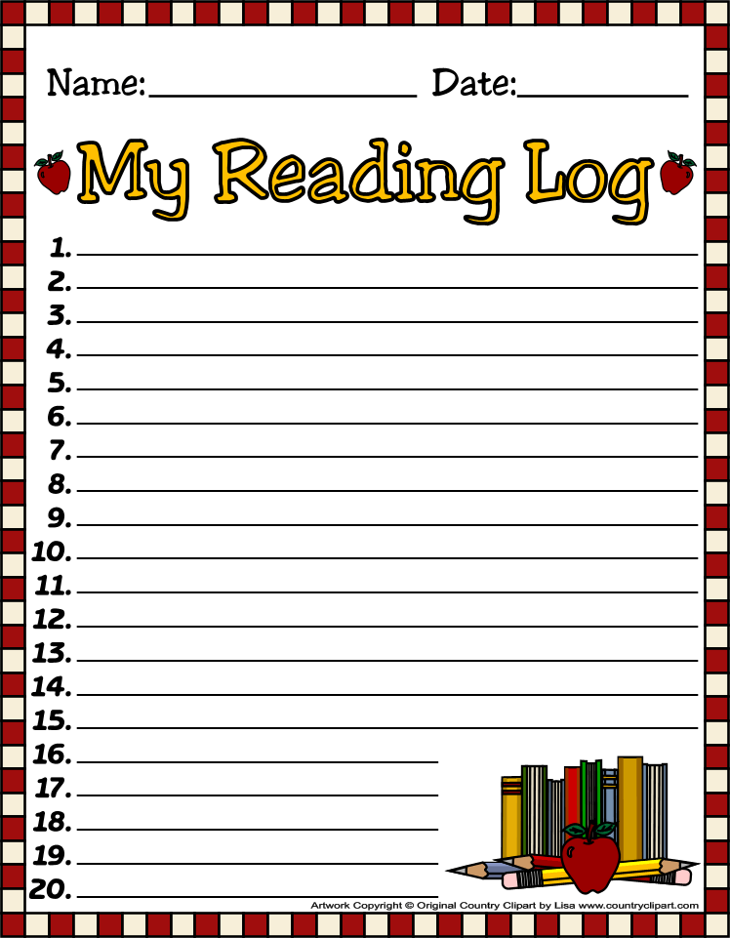 |  | Mrs. Trotter will do Guidance lesson 9:30-10:00 am | All Homework is due today.  Library 1:45-2:30  Don’t forget your books. Librarian wants me inform everyone to remember to return books because we have a lot that are overdue. | Friday Morning Assembly 7:45  Spelling Test 8:00  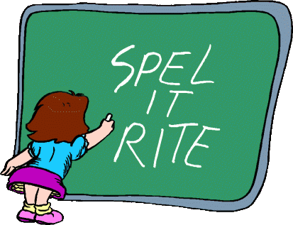  DEAR Time 8:15-9:45 Bring Books, Towel, and small stuffed animal.  Peace Fest 10:00-10:45
3/17/14 | 3/18/14 | 3/19/14 | 3/20/14 | 3/21/14
Dear Parents,
I hope everyone had a wonderful week off! I am so excited to be returning. I have found some really fun lessons for this next quarter. We are getting closer to the end of the school year and we still need to focus on our learning. Sometimes it is difficult for students to stay focused after spring break because they know it’s getting close to the end of the school year and spring fever is in the air. However, I will need your assistance to remind the children that there is still plenty to learn and they should continue to do their best.
Homework research paper was sent home last week. It will be due with the Math on Thursday. Thank you for your support.
Last week, Audrey did a fabulous job as the Star of the Week. Thank you for doing a fantastic job! I really loved your poster!
EOY Assessment Dates are April 14-May 16th. I will not begin testing until May to give the children ample time to develop their final reading scores. Please remember to read daily.
Academic Focus:
Math-
Week 27 Problems and Number Sentences
Week 28 Problems and Properties of Numbers
Science:
Week 27-36 Organisms & Environments
Language Arts:
Reading-inferences, comprehension, draw conclusions, build vocabulary, alphabetizing words to first and second letters, retelling stories
Writing- Poetry
Social Studies: Women’s History and Leadership
Spelling Words: Rules for K sound.
The (k) sound before a,o,u,or a consonant= c (cup).
The (k) sound before e, i, or y = k (kite)
cannot, cap, cast, cling, cost, cramp, crust, cup, green, keel, kelp, kept, kid, skill, skip
Challenge Words: leprechaun, March, scuff
Events:
- March 28, 2014 Friday (Readers Theater and brunch)
- March 31, 2014- Capital (Leah P. & Cherie B.)

Have a Great Week!
Mrs. Cavazos

