Mrs. Cavazos’ Weekly Newsletter #28
Monday | Tuesday | Wednesday | Thursday | Friday
Monday Morning Assembly 7:45  Math Homework sent home today. Research homework was sent on Friday. All work is due on Thursday. Please remember to read daily and document in reading log.  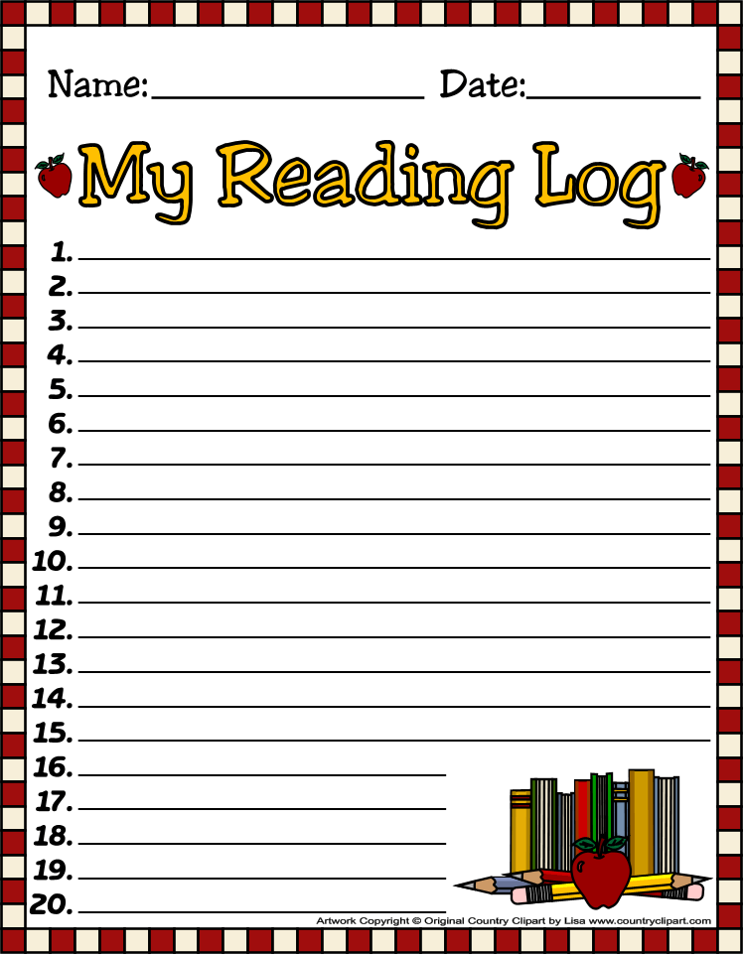  Olivia is the Star of the Week. | Don’t forget to read daily and document in reading log. | Library 9-9:30  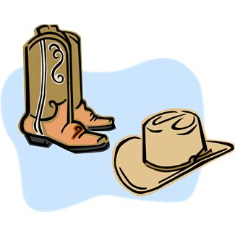  Don’t forget to dress up today like a cowboy or a cowgirl. All four first grade classes will be dressed up. (Even the teachers) Come to school dressed.  Report cards go home today. | All Homework is due today.(Women in History and math)  Dress rehearsal today. We will perform for Kinder and Mr. Dowell’s class at 9:00. | Friday Morning Assembly 7:45  Spelling Test 8:00  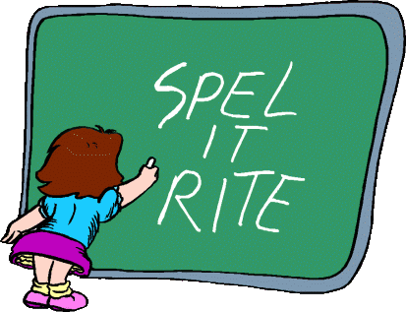  Reader’s Theater 8:50 (cafeteria) Brunch will be shortly after performance in the classroom.  Field trip on Monday 3/31 don’t forget your lunch. Leah and Cherie will chaperone. We leave by *8:50.
3/24/14 | 3/25/14 | 3/26/14 | 3/27/14 | 3/28/14

Dear Parents,
I hope you had a terrific weekend! We were busy this past week with St. Patrick’s Day activities, planting, experimenting with lentils, making observations, documenting, predictions, writing poetry about spring and acrostic poems of our name. We are in the process of writing a leprechaun story. We are filling out the graphic organizer with characters, setting, plot and solution. It is still a work in progress. We also started our subtraction topic in math. I send home some practice math work sheets. They are not for homework. They are for students who may need or want extra practice. Please do not return this work. Thank you!
Homework research paper was sent home last week. It will be due with the Math on Thursday. Thank you for your support. The children say they like the research homework. I hope it is not over whelming.
Last week, Madison did a terrific job as the Star of the Week. Thank you for doing a fantastic job! We really loved your poster! She read a book about Sponge Bob and she did a terrific job reading. I hope everyone had an opportunity to check out her poster it was terrific. The children wrote letters to Madison. Most of them were about how much they will miss her and they hope she makes friends.
The library time is shortened this week. We will have an opportunity to check out books. Please remember to bring your books..
EOY Assessment Dates are April 14-May 16th. I will not begin testing until May to give the children ample time to develop their final reading scores. Please remember to read daily.
Attire for children at Readers Theater: The girls should were a black pants or leggings or a black skirt. Boys should wear black pants and a white shirt.
Academic Focus:
Math-
Week 28 Problems and Properties of Numbers, subtraction
Science:
Week 28-36 Organisms & Environments
Language Arts:
Reading-inferences, comprehension, draw conclusions, build vocabulary, alphabetizing words to first and second letters, retelling stories
Writing- Expository research
Social Studies: Women’s History and Leadership
Spelling Words: We are on week 28
Week 28
The (k) sound in final position in a one syllable base word after a short vowel= ck (truck)
The (k) sound in a final position after a consonant or a vowel pair = k (bank, book)
black, block, dock, duck, lick, lock, luck, neck, sack, sock, stick, struck, tick, trick, truck
Challenge Words: organism, plants, soil
Spelling list for next week
Week 29
Rules for (ng) sound in medial or final position=ng (king)
The (ng) sound before the (k) sound or the (g) sound = n (sink)
bang, clang, fang, fling, gong, hang, king, long, ping, sang, sing, slang, sling, song, sting
Challenge Words: Texas, Austin, capital
Events:
- March 28, 2014 Friday (Readers Theater and brunch)
- March 31, 2014- Capital (Leah P. & Cherie B.)

Have a Great Week!
Mrs. Cavazos

