Mrs. Cavazos’ Weekly Newsletter #29
Monday | Tuesday | Wednesday | Thursday | Friday
Monday Morning Assembly 7:45  Math Homework sent home today. Research homework was sent on Friday. All work is due on Thursday. Please remember to read daily and document in reading log.  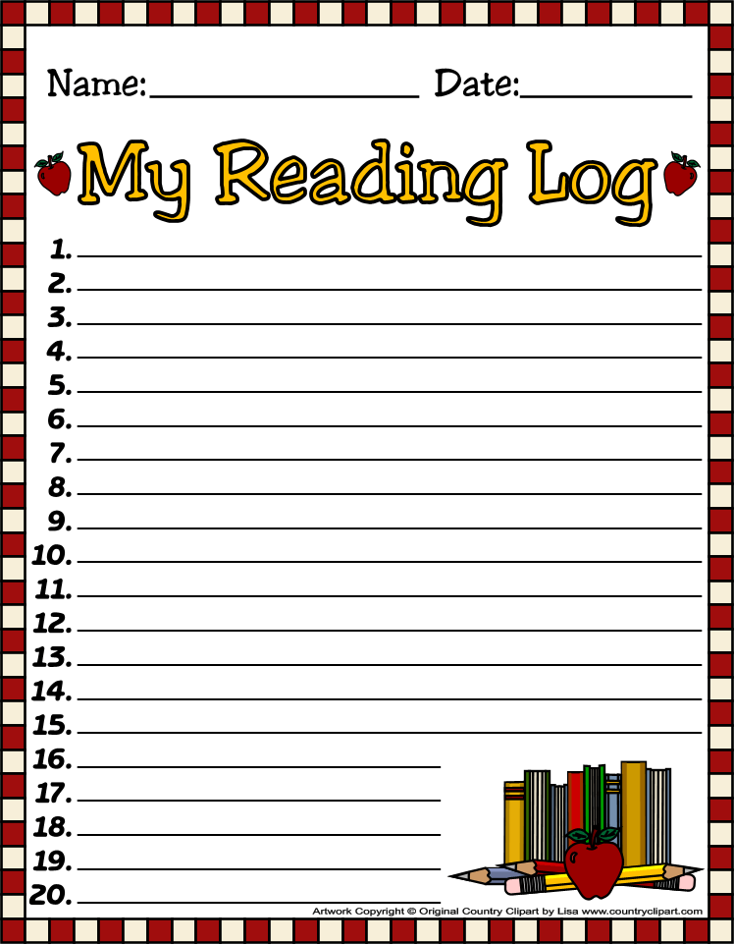  Kai is the Star of the Week. 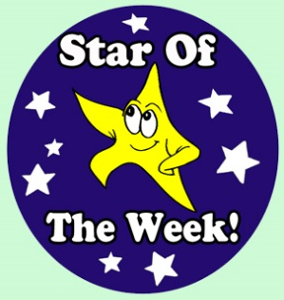  Field trip to the capital | Don’t forget to read daily and document in reading log. | 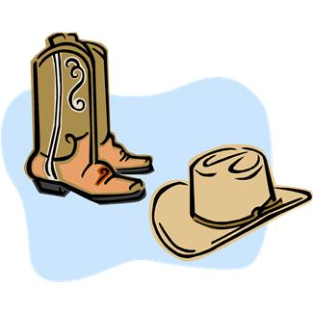  Don’t forget to dress up today like a cowboy or a cowgirl. All four first grade classes will be dressed up. (Even the teachers) Come to school dressed. | All Homework is due today. (math)  Library 1:45-2:30 | Friday Morning Assembly 7:45  Spelling Test 8:00  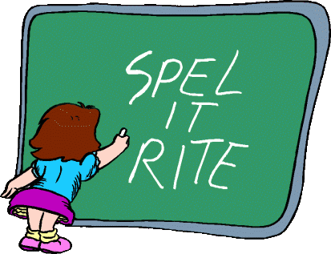
3/31/14  PE | 4/1/14  Music | 4/2/14  Art | 4/3/14  PE | 4/4/14  Music
Dear Parents,
I hope you had a terrific weekend! I cannot thank you enough for the wonderful celebration you provided for the children after readers theater. They loved the food and flowers. They especially loved that you were there for them. It meant the world to them. Thoughts from students; we should have charged money like in plays and sent the money to Africa, we should do this more often, it went by so quick,… I thought the comments were so sweet. I want to thank the parents that took pictures. I’m sure parents will appreciate the pictures because this was a wonderful moment in their lives.
Parents, I want to thank you all for taking time off your busy day schedule to see your child perform. It meant the world to them. Your comments from your reviews were so touching and inspiring. Some children chose to take their performance reviews home others chose to keep it in their binder.
A word of wisdom: Please remember to tell your child each and every day how much you love them and how they mean the world to you. They grow up so fast!
Academic Focus:
Math-
Week 28 Measurement length
Science:
Week 28-36 Organisms & Environments This week we will focus on organisms resemble their parents, how they help them survive their environment, record life cycles of animals such as chickens, frogs and fish.
Language Arts:
Reading-inferences, comprehension, draw conclusions, build vocabulary, alphabetizing words to first and second letters, reading comprehension, understanding the author’s purpose.
Writing- writing process and procedural text.
Social Studies: Women in history and pollution.

Spelling List Week 29
Rules for (ng) sound in medial or final position=ng (king)
The (ng) sound before the (k) sound or the (g) sound = n (sink)
bang, clang, fang, fling, gong, hang, king, long, ping, sang, sing, slang, sling, song, sting
Challenge Words: Texas, Austin, capital
Events:
- March 31, 2014- Capital (Leah P. & Cherie B.) Thank you parents!
Star of the Week Schedule
- April 7 Nora
- April 14 Henry
- April 21 Lucian
- April 28 Coen
- May 5 Hughes
- May 12 Leo
- Make up days Eliana May 19 and 20, Sophia May 21, Leilani May 22 and 23, McKenna May 26
- Due to bad weather or illnesses.
Have a Great Week!
Mrs. Cavazos

