Mrs. Cavazos’ Weekly Newsletter #30
Monday | Tuesday | Wednesday | Thursday | Friday
Monday Morning Assembly 7:45  Math Homework sent home today. Please make sure to read daily and document in reading log.  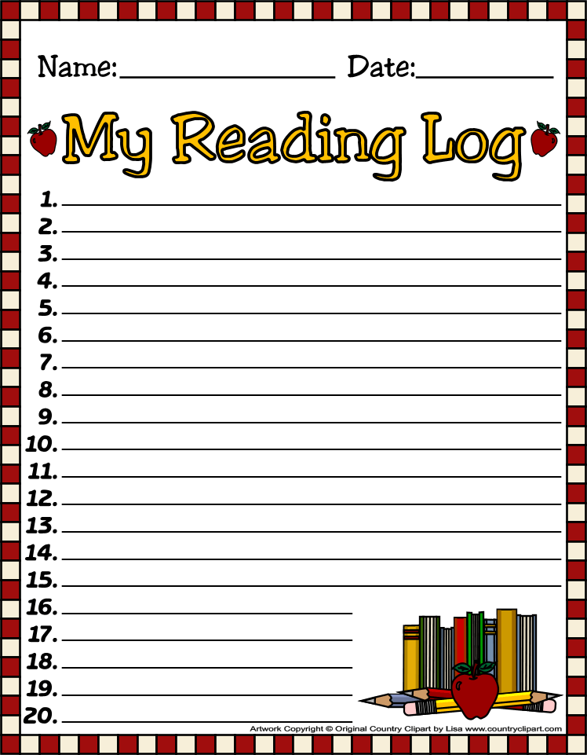  Nora is the Star of the Week. 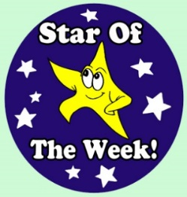  CAC Meeting afterschool 3:00. | Don’t forget to read daily and document in reading log. | Don’t forget to read daily and document in reading log.  Mrs. Trotter Guidance at 9:30 | All Homework is due today. (math)  Library 1:45-2:30  Don’t forget your books!  Don’t forget to read daily and document in reading log. | Friday Morning Assembly 7:45  We need parent readers please remember to sign up by the classroom. The children love when you read. Thanks  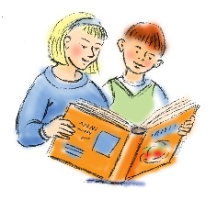  Spelling Test 8:00  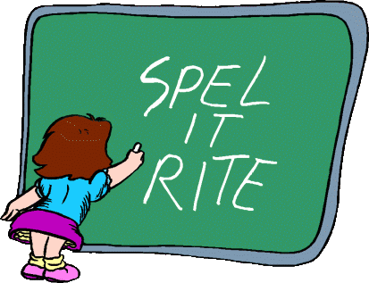  Mrs. Cavazos will be out today. My son will be presenting at the HEB Slimdown Showdown.
4/7/14  Art | 4/8/14  PE | 4/9/14  Music | 4/10/14  Art | 4/11/14  Music
Dear Parents,
I hope you had a terrific weekend! Last week we learned a lot. We read about Helen Keller and how she was very instrumental with helping the blind. We learned of her up-bringing and how she learned. Just because someone has a disability does not mean that they are not capable of learning. We just have to find a different way to learn and we should never give up.
We also learned about estimation and measurement. We ordered the measurement by capacity, length, and area. We used tiles and scales to measure different items. We compared and ordered them from greatest to least and least to greatest.
We have been writing stories and using graphic organizers to organize our information. The children are realizing it takes focus and time to write. We will continue to work on the writing process skills. I model and with the help of the students we wrote a silly story of the first grade teachers. They laughed during the story I shared it with some of the other teachers.
We learned about the chicken’s life cycle. We had reading buddies and we did a little computer time. Several computers are down so we buddied up. They children are very capable of doing it independently. Way to go! They are getting ready for second grade. Can you believe that?
Kai did a great job as the Star of the Week. He read a cute story. His poster was adorable and he did a great job leading the class. Thank you for being such a great leader and setting a great example for others to follow.
Thank you parents for coming to Lunch Bunch!
Academic Focus:
Math-
Week 30&31 Measurement with two different units.
Week 32-34 Picture and Bar Graphs
Week 34-36 Generating and Solving Problems
Science:
Week 28-36 Organisms & Environments This week we will focus on organisms resemble their parents, how they help them survive their environment, record life cycles of animals such as chickens, frogs and fish.
Language Arts:
Reading-inferences, comprehension, draw conclusions, build vocabulary, alphabetizing words to first and second letters, reading comprehension, understanding the author’s purpose.
Writing- writing process and procedural text.
Social Studies: Natural Resources and pollution.

Spelling List Week 30 (this week)
Rules for (n) sound in initial, medial or final position=n (nest)
nip, tint, snap, in, pin, tin, sin, spin, nest, not, neck, next, tent, hand, plan
Challenge Words: April, organisms, environment

Events:
Field Trip Zach Theater April 24th. Emily to assist.
Star of the Week Schedule
- April 14 Henry
- April 21 Lucian
- April 28 Coen
- May 5 Hughes
- May 12 Leo
- Make up days Eliana May 19 and 20, Sophia May 21, Leilani May 22 and 23, McKenna May 26
- Due to bad weather or illnesses.
Have a Great Week!
Mrs. Cavazos

