Mrs. Cavazos’ Weekly Newsletter #31
Monday | Tuesday | Wednesday | Thursday | Friday
Monday Morning Assembly 7:45  Math Homework sent home today. Please make sure to read daily and document in reading log.  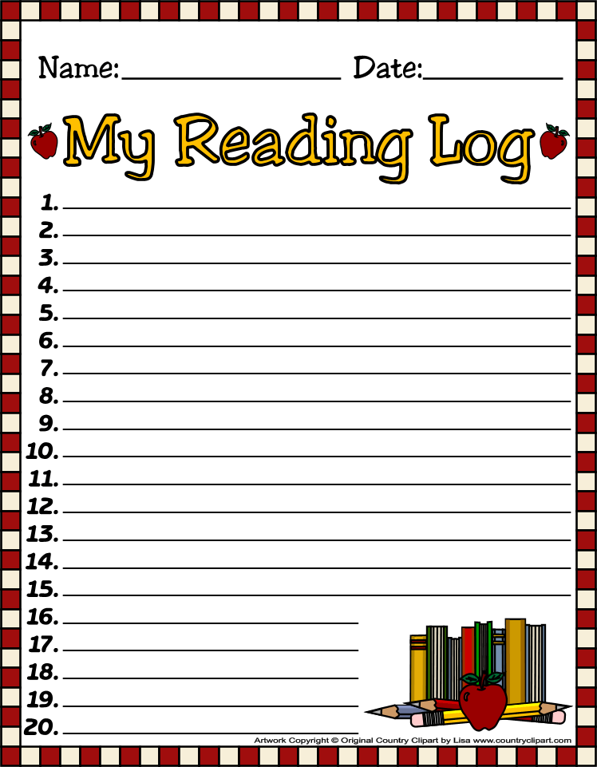  Henry is the Star of the Week. | Don’t forget to read daily and document in reading log. | Don’t forget to read daily and document in reading log. | We need parent readers please remember to sign up by the classroom. The children love when you read. Thanks  Spelling Test  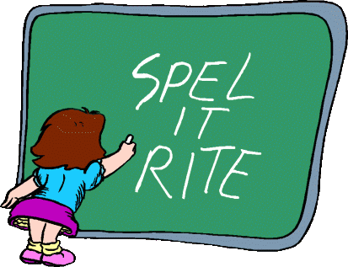  All Homework is due today. (math)  Library 1:45-2:30  Don’t forget your books!  Don’t forget to read daily and document in reading log. | No School today have a wonderful 3 day weekend!
4/14/14 | 4/15/14 | 4/16/14 | 4/17/14 | 4/18/14
Dear Parents,
We are learning to add by 10’s and using the hundreds chart. Going down rows is counting by 10’s, moving right is adding by ones, moving left is subtracting by ones, and moving up rows is subtracting by 10’s. I will send practice math sheets for those wanting extra practice at home. They do not need to be returned. Thanks, they will be posted with a note that states for practice only. Friday, I left a math packet to review with the sub over money. I thought it would be a good time to review money concepts. Money is one of the more difficult concepts to learn. They have to learn how to identify coins, know the value and be able to add the coins.
I hope everything went well on Friday.
We have been reading Dr. Doolittle an old classic and the children love the story. I will tie a craft and a writing piece to it when we are done.
We have a short week this week. I hope everyone will have a safe and happy holiday!
Nora was the Star of the Week. She did a fantastic job reading! I hope everyone was able to see her poster. Can you believe she had brown hair when she was born? Thank you for being such a great leader and setting a great example for others to follow.

Academic Focus:
Math-
Week 30&31 Measurement with two different units and addition.
Week 32-34 Picture and Bar Graphs
Week 34-36 Generating and Solving Problems
Science:
Week 28-36 Organisms & Environments This week we will focus on organisms resemble their parents, how they help them survive their environment, record life cycles of animals such as chickens, frogs and fish.
Language Arts:
Reading-inferences, comprehension, draw conclusions, build vocabulary, alphabetizing words to first and second letters, reading comprehension, understanding the author’s purpose.
Writing- writing process and short stories.
Social Studies: Natural Resources and pollution.

Spelling List Week 31 (this week) Since this is a short week, I am giving fewer words. Rules for (oo) sound in initial or medial position = (book)
good, hood, stood, hoof, soot, cook, took, look, hook, rook, crook
Challenge Words: Saturday. Sunday, Friday

Events:
Field Trip Zach Theater April 24th. Emily to assist. We will leave approx. 11:25 we will eat lunch earlier we will return by 1:30.
Star of the Week Schedule
- April 21 Lucian
- April 28 Coen
- May 5 Hughes
- May 12 Leo
- Make up days Eliana May 19 and 20, Sophia May 21, Leilani May 22 and 23, McKenna May 26
- Due to bad weather or illness.
Have a Great Week!
Mrs. Cavazos
I know this doesn’t have to do with school but, I thought I would share a little of my family. If you would like to view this video, it is of my son. He also made a commercial for the American Heart Association that will be aired later this week. This is where I was Friday to support him.
http://youtu.be/Fc77nPAqbVU
Thank you for all you do!

