Mrs. Cavazos’ Weekly Newsletter #32
Monday | Tuesday | Wednesday | Thursday | Friday
Monday Morning Assembly 7:45  Math Homework sent home today. Please make sure to read daily and document in reading log.  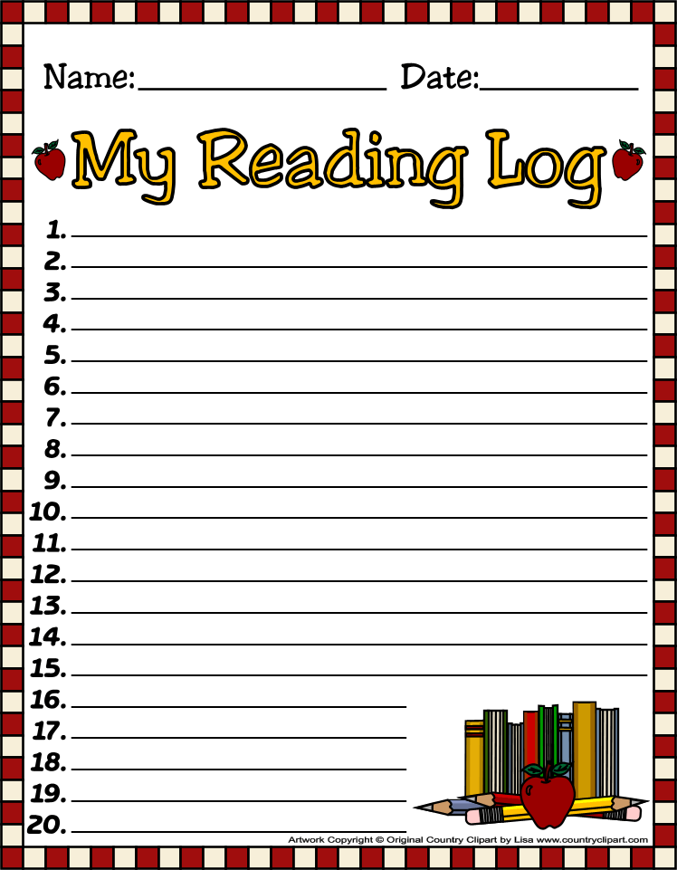  Lucian is the Star of the Week. | Don’t forget to read daily and document in reading log. | Don’t forget to read daily and document in reading log. | All Homework is due today. (math)  Zack Theater Field Trip  Leave approx. 11:15-11:25  Library 1:45-2:30 Don’t forget your books.  Don’t forget to read daily and document in reading log. | Assembly 7:45  Parent Reader 8:05  Spelling Test 8:25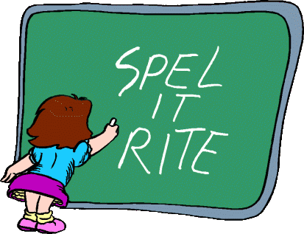  Reading Buddies 1:10-1:40
4/21/14 | 4/22/14 | 4/23/14 | 4/24/14 | 4/25/14
Dear Parents,
I hope everyone had a wonderful 3 day weekend! This week we will be going on a field trip to the Zach Theater to watch Pinocchio. Our special areas time will change. We will go to specials at 9:15-10:00 on April 24th. We will be eating in the classroom. Please bring a sack lunch. In order for us to eat and be ready for our field trip we have to eat earlier. The bus will leave no later than 11:20. We will return by 1:30. Emily will be our chaperone.
HENRY was the Star of the Week. Did you see his poster! I hope everyone saw it. It was terrific. We will write to Henry on Monday since not everyone was here. Thank you Henry for being such a great leader.
Thank you Alana for reading to the class. I hope you enjoyed the thank you booklet the children made you. There were some amazing illustrations.
I introduce a fun lesson on Thursday on Bar graphs. The children graphed the different colors of M&M candies they received. We discussed how graphs are a way to organize information. Once the children graphed the M&M’s according to color. Then, they had to compare and answer questions using their graphs. They did a terrific job. Then the fun part came, they could eat their data when they completed their assignment.

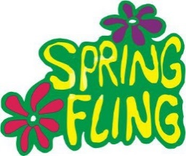Emily and Leah are needing your support for Spring Fling. Please support the PTA. All funds are collected for the children. Thanks for your help!
I have donated a lunch for a child and his /her friend with the teacher during lunch time at Hilbert’s.
This week there will be Starr testing. During the Starr testing, we are not able to go outside to play so we have indoor recess. I will include some kind of movement and maybe a new dance.
Academic Focus:
Math-
Week 32-34 Picture and Bar Graphs
Week 34-36 Generating and Solving Problems
Science:
Week 28-36 Organisms & Environments This week we will focus on organisms resemble their parents, how they help them survive their environment, record life cycles of animals such as chickens, frogs and fish.
Language Arts:
Reading-inferences, comprehension, draw conclusions, build vocabulary, alphabetizing words to first and second letters, reading comprehension, understanding the author’s purpose.
Writing- writing process and short stories.
Social Studies: pollution , recycle, reuse, reduce.

Spelling List Week 32 (this week) final k sound
kink, clank, lock, stack, duck, luck, black, neck, mock, ask, bank, honk, sank, think, book
Challenge Words: fantastic, metric, plastic

Terrarium Project
We will need parental support on a project that I plan to do that is tied to living organisms and the rain forest. I will post a volunteer sign up on living tree and you can sign up for what you can purchase for the children. I have collected half gallon containers for each child.
Best Plants see list below: Each child will need to bring at least 2 plants from the following list: Please try to get different heights of plants. It should be fun building these terrariums. Try to get a creeping plant and a focal tall plant. Please bring all supplies by Thursday.
- Spider fern
- Lemmon button fern
- Mini English Ivy
- Creeping Fig
- Baby tears
- Aluminum Plant
- Hypoestes
- Mini Palms
- Pilea
- Mini Ferns
- Miniature African violets
- Small figurines optional such as dinosaurs, fairies, mushrooms, shells. Etc..
We will need:
River gravel for drainage
Potting Soil
Plastic teaspoons
Larger stones
Charcoal

Events:
Field Trip Zach Theater April 24th.
Spring Fling
Mother’s Day May 11th.
Star of the Week Schedule
- April 28 Coen
- May 5 Hughes
- May 12 Leo
- Make up days Eliana May 19 and 20, Sophia May 21, Leilani May 22 and 23, McKenna May 26
- Due to bad weather or illness.
Have a Great Week!
Mrs. Cavazos

