Mrs. Cavazos’ Weekly Newsletter #33
Monday | Tuesday | Wednesday | Thursday | Friday
Monday Morning Assembly 7:45  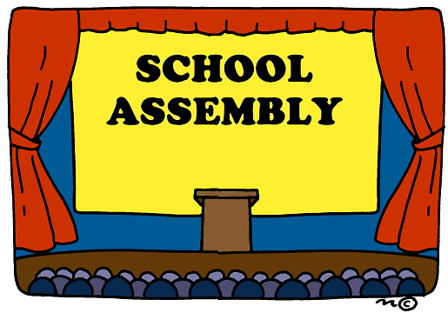  Math Homework and research paper form sent home today. Please make sure to read daily and document in reading log.  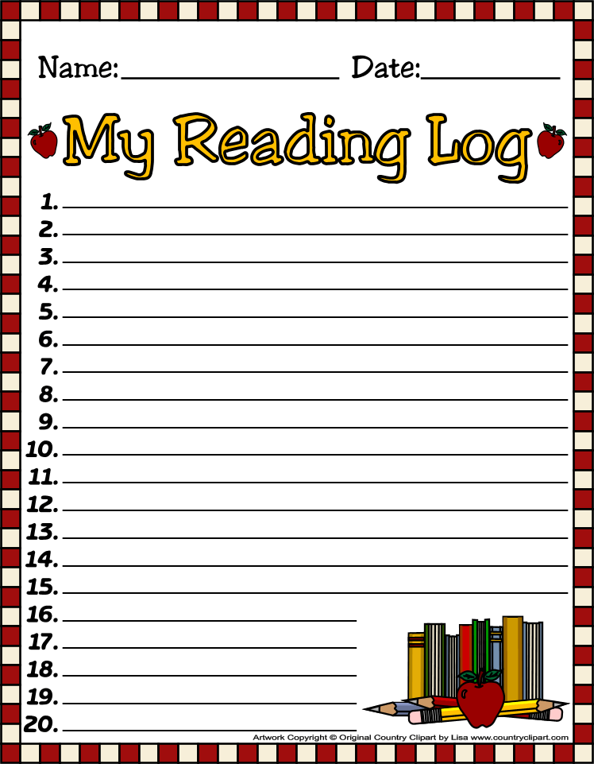  Coen is the Star of the Week. 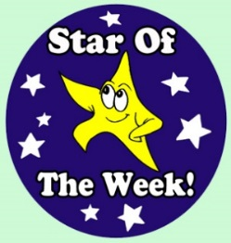 | Don’t forget to read daily and document in reading log. | Don’t forget to read daily and document in reading log. | All Homework is due today. (math)  Library 1:45-2:30 Don’t forget your books.  Don’t forget to read daily and document in reading log. | Assembly 7:45  Parent Reader 8:05  Spelling Test 8:25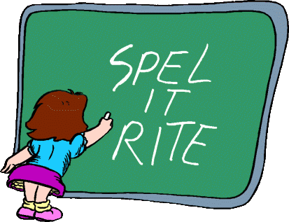
4/28/14  Music | 4/29/14  Art | 4/30/14  PE | 5/1/14  Music | 5/2/14  Art
Dear Parents,
I hope everyone enjoyed their weekend and their amazing terrariums. You can look up how to care for terrariums on line. They seem pretty simple. The children did a fantastic job can you believe it only took 45 minute for the entire class to complete the terrariums.

Lucian was the Star of the Week. Did you see his cute poster! I hope everyone saw it. It was terrific. Those were some cute pictures of him and his sister. Thank you Lucian for being such a great leader. I know that you said you have more fun being the door holder but you did a great job as the line leader.
Thank you Julia for reading to the class. I hope you enjoyed the thank you booklet the children made you. Sorry you had to wait but thank you for being so patient while Ms. Sharpe’s class used our room. I heard her Reader’s Theater was a great success. I know how hard teachers and students work on it but it is worth it because children feel so confident afterwards.

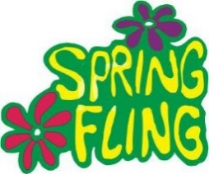Emily and Leah are needing your support for Spring Fling. Please support the PTA. All funds are collected for the children. Thanks for your help!
I have donated a lunch for a child and his /her friend with the teacher during lunch time at Hilbert’s.
Thank you parents for attending Lunch Bunch! I was so glad to see so many parents. We were able to give a little preview of one of our dances because the computer worked that day.
Academic Focus:
Math-
Week 32-34 Picture and Bar Graphs
We will be writing surveys and asking people to take the surveys on the playground. Then we will be graphing our data.
Week 34-36 Generating and Solving Problems
Science:
Week 28-36 Organisms & Environments This week we will focus on organisms resemble their parents, how they help them survive their environment, record life cycles of animals such as chickens, frogs and fish.
Language Arts:
Reading-inferences, comprehension, draw conclusions, build vocabulary, alphabetizing words to first and second letters, reading comprehension, understanding the author’s purpose.
Writing- writing process and short stories.
Social Studies: week 33 litter, reduce, reuse, recycle, going green
Week 34 Cinco de Mayo
Week 35 Goods and Services

Spelling List Week 33 (this week) final k sound and the magic e
cake, lake, take, bake, make, wake, rake, like, bike, hike, joke, shake, broke, smoke, strike
Challenge Words: broke, snake, quake

Events:
Spring Fling 5/4/14
Research on Marine Life is due 5/7/14.
Mother’s Day May 11th
June 2nd Monday 6:15-7:15 Please save the date and time for a special event in the cafeteria for our class only. Leah will contact you later with more info.
Star of the Week Schedule
- May 5 Hughes
- May 12 Leo
- Make up days Eliana May 19 and 20, Sophia May 21, Leilani May 22 and 23, McKenna May 26
- Due to bad weather or illness.
Have a Great Week!
Mrs. Cavazos

