Mrs. Cavazos’ Weekly Newsletter #34
Monday | Tuesday | Wednesday | Thursday | Friday
Monday Morning Assembly 7:45  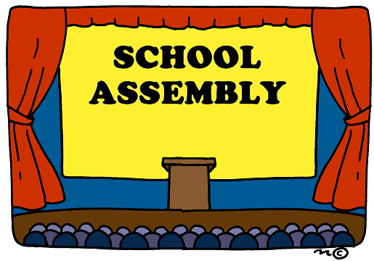  Parent Reader Jake 8:05  Math Homework sent home today.  Please make sure to read daily and document in reading log.  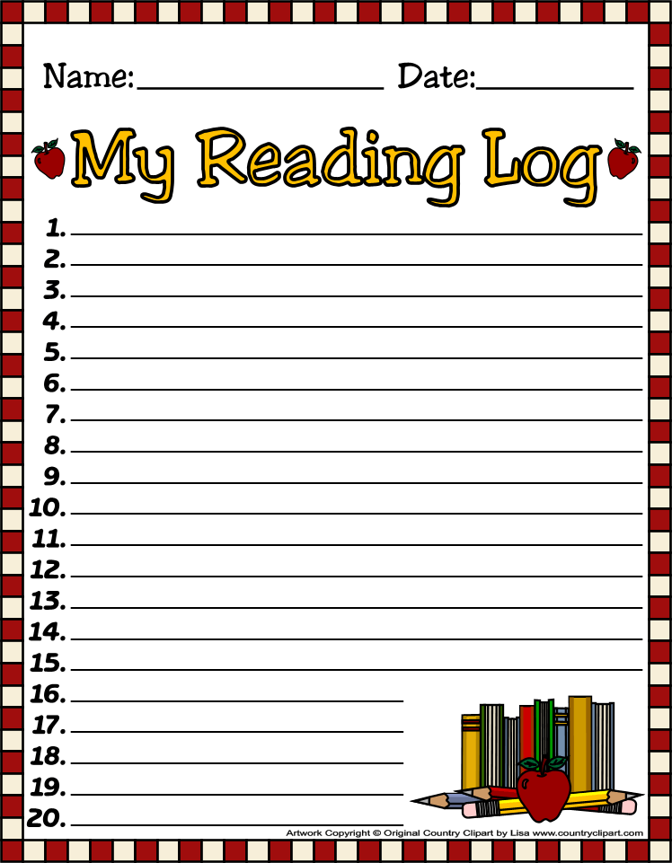  Hughes is the Star of the Week. 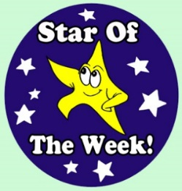  CAC Meeting at 3:05 today!  Sounds a little Fishy to me a Second grade MARE kick off performance @ 2:00 in cafeteria. | Don’t forget to read daily and document in reading log.  Bring something educational that you would like to share with the class. | Don’t forget to read daily and document in reading log.  Guidance with Mrs. Trotter @9:30  Marine Life Research is due.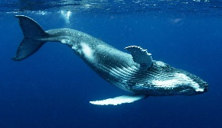 | All Homework is due today. (math)  Library 1:45-2:30 Don’t forget your books.  Don’t forget to read daily and document in reading log. | Assembly 7:45  Parent Reader 8:05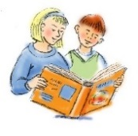  Spelling Test 8:25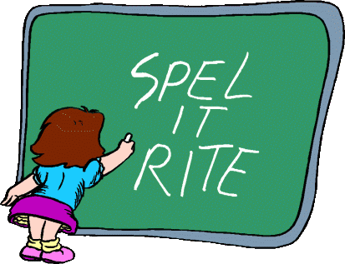
5/5/14  PE | 5/6/14  Music | 5/7/14  ART | 5/8/14  Music | 5/9/14  Art
Dear Parents,
I hope everyone enjoyed their weekend and had a terrific time at Spring Fling. It was so nice to see so many parents supporting the PTA. I really enjoyed myself. It was a wonderful evening!
Coen was the Star of the Week. He made a double sided poster! I hope everyone saw his pictures. There were a lot of pictures. I could see the family resemblance in his photos. We enjoyed his story and listening to him read. Thanks for a great week!
Thank you Emily for reading to the class they really enjoyed the books you read. We will complete our thank you letters to you early this week.
Academic Focus:
Math-
Week 32-34 Picture and Bar Graphs
We will be writing surveys and asking students and teachers to take the surveys on the playground. Then we will be graphing our data.
Week 34-36 Generating and Solving Problems
Science:
Week 28-36 Organisms & Environments This week we will focus on organisms resemble their parents, how they help them survive their environment, record life cycles of animals such as chickens, frogs and fish.
Language Arts:
Reading-making inferences in plots, comprehension, sequence of events, making connections, recurring phrases.
Writing- the writing process is recursive. Students work through if according to abilities and genre. The students use the elements of the writing process. (Planning, drafting, revising, editing, and publishing.
Social Studies:
Week 34 Cinco de Mayo
Week 35 Goods and Services

Spelling List Week 34 (this week) th sound
that, than, then, those, rather, bother, northern, worthy, farther, think, thick, thank, with, bath, teeth,
Challenge Words: panther, strength, thunder
________________________________________________________________
Events:
Research on Marine Life is due 5/7/14.
Mother’s Day May 11th
Mrs. Cavazos will be out May 12th
Parent Volunteer Luncheon May 15th 11:05-1:05 Everyone is invited. I have had so many parents involved this year from reading, computer lab, special projects, photography, parties, supplies and donations. The list can go on and on. Please make the time to join us. This is just a small token of my appreciation to honor you for all you have done.
May 21 Water Day K-2nd (Fun, Fun, Fun!)
June 2nd Monday 6:15-7:15 Please save the date and time for a special event in the cafeteria for our class only. Leah will contact you later with more info.
Star of the Week Schedule
- May 12 Leo
- Make up days Eliana May 19 and 20, Sophia May 21, Leilani May 22 and 23, McKenna May 26
Due to bad weather or illness.
Have a Great Week!
Mrs. Cavazos

